

PLANO DE AULA
Aula 07 | Tempo estimado: 1 hora e 30 minutos | Faixa-Etária: Game Advanced
Tipo da atividade: No computador
Ferramenta(s): Unity 3D

Conteúdos
- Sistema de Combate

Objetivos
- Configurar sistema de combate do Player.

Estratégias e atividades

Para dar continuidade ao sistema de ataque que iniciamos na aula anterior, precisamos fazer alterações no script do Player para integrar as mecânicas de combate com o sistema de movimento já implementado. Vamos adicionar a lógica de detecção de inimigos, controle de foco de alvo e a execução dos ataques.

START

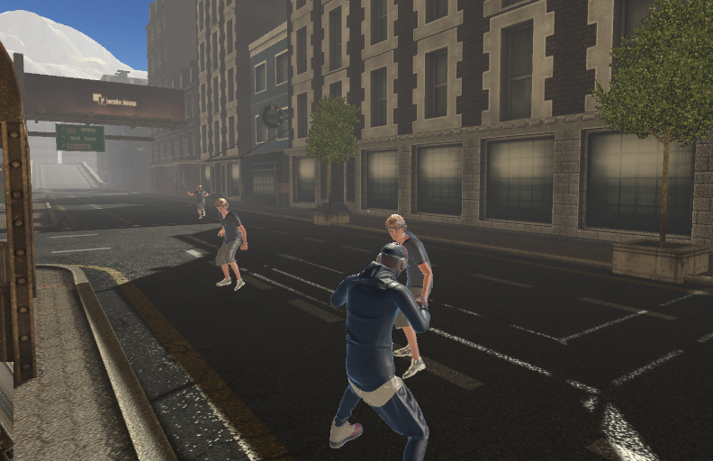

Altere o script do Player:

using System;
using System.Collections;
using System.Collections.Generic;
using System.ComponentModel.Design;
using System.Threading;
using Cinemachine;
using JetBrains.Annotations;
using TMPro;
using Unity.VisualScripting;
using UnityEngine;
using UnityEngine.Animations.Rigging;
using UnityEngine.EventSystems;
using UnityEngine.InputSystem;
using UnityEngine.TextCore.Text;
using UnityEngine.UI;
using static Cinemachine.CinemachineFreeLook;
using static NPC;

public class Player : MonoBehaviour
{
public enum PlayerState
{
Passive,
Agressive,
Dead
}

[Header("Player Status")]
public PlayerState state;
public float health;
public bool isHit;
public bool isDead;

[Header("Movement")]
public float playerSpeed;
public float playerSprint;
public float currentSpeed;
public float smoothSpeed;
public float jumpRange;
Vector3 velocity;

[Header("Animation")]
public CharacterController playerController;
public RuntimeAnimatorController animController;
public RuntimeAnimatorController combatController;
public Animator anim;

[Header("Combat")]
public List<GameObject> enemyGroup;
public GameObject enemyFocus;
public bool isAttacking;
public float timeAttack;
public int attackCount;
public float damage;

[Header("Camera")]
public Transform camTransform;
public Transform headTransform;
public Transform targetTransform;
public LayerMask targetMask;
public CinemachineFreeLook freeLookCam;
public CinemachineFreeLook combatCam;
public float turnSmoothTime;
float turnSmoothVelocity;

[Header("Gravity")]
public Transform surfaceCheck;
public LayerMask surfaceMask;
public float surfaceDistance;
public float gravity;
public bool onSurface;

[Header("Input")]
public Controls controls;

private void Awake()
{
UnityEngine.Cursor.visible = false;
UnityEngine.Cursor.lockState = CursorLockMode.Locked;
controls = new Controls();
controls.Enable();
}

void Start()
{
playerSpeed = 2f;
playerSprint = 5f;
smoothSpeed = 10f;
currentSpeed = 0f;
isAttacking = false;
isDead = false;
timeAttack = 1f;
attackCount = 0;
damage = 20f;
jumpRange = 0.5f;
turnSmoothTime = 0.1f;
surfaceDistance = 0.4f;
enemyFocus = null;
gravity = -9.8f;
}

void FixedUpdate()
{
if (!isDead)
{
Gravity();

if(controls.Player.ChangeState.triggered)
{
AlternateState();
}

switch (state)
{
case PlayerState.Passive:

isAttacking = false;
isHit = false;
anim.runtimeAnimatorController = animController;
combatCam.Priority = 8;

Move();

break;
case PlayerState.Agressive:

anim.runtimeAnimatorController = combatController;
combatCam.Priority = 11;

Move();
Combat();

break;
case PlayerState.Dead:

Die();

break;
}
}
else
{
anim.SetBool("isDead", true);
combatCam.gameObject.SetActive(false);
freeLookCam.gameObject.SetActive(true);
}
}

private void Gravity()
{
onSurface = Physics.CheckSphere(surfaceCheck.position, surfaceDistance, surfaceMask);

if (onSurface && velocity.y < 0)
{
velocity.y = -2f;
}

velocity.y += gravity * Time.deltaTime;
playerController.Move(playerSpeed * Time.deltaTime * velocity.normalized);

anim.SetBool("OnSurface", onSurface);
}

public void AlternateState()
{
if (!isAttacking && !isHit)
{
if (state == PlayerState.Passive && enemyGroup.Count > 0)
{
state = PlayerState.Agressive;
SetEnemyFocus();
}
else if (state == PlayerState.Agressive)
{
state = PlayerState.Passive;
}
}
}

private void Move()
{
float inputX = controls.Player.Move.ReadValue<Vector2>().x;
float inputZ = controls.Player.Move.ReadValue<Vector2>().y;
float moveSpeed;

Vector3 direction = new Vector3(inputX, 0, inputZ).normalized;
float targetAngle = Mathf.Atan2(direction.x, direction.z) * Mathf.Rad2Deg + camTransform.eulerAngles.y;
float angle = Mathf.SmoothDampAngle(transform.eulerAngles.y, targetAngle, ref turnSmoothVelocity, turnSmoothTime);

moveSpeed = (controls.Player.Sprint.IsPressed() ? playerSprint : playerSpeed);
transform.rotation = Quaternion.Euler(0, angle, 0);

Vector3 moveDirection = Quaternion.Euler(0, targetAngle, 0) * Vector3.forward;

if (direction.magnitude >= 0.1f)
{
playerController.Move(moveSpeed * Time.deltaTime * moveDirection.normalized);
currentSpeed = Mathf.Lerp(currentSpeed, moveSpeed, smoothSpeed * Time.deltaTime);
}
else
{
currentSpeed = Mathf.Lerp(currentSpeed, 0, smoothSpeed * Time.deltaTime);
}

anim.SetFloat("Speed", currentSpeed);
}

public void Combat()
{
if (enemyFocus != null)
{
Vector3 target = new Vector3(enemyFocus.transform.position.x, transform.position.y, enemyFocus.transform.position.z);

if (enemyGroup.Count > 0)
{
if (enemyFocus.GetComponent<NPC>().isAgressive)
{
transform.LookAt(target);
}
}
else
{
Invoke("AlternateState", 2f);
}
}

if (controls.Player.Attack.triggered && !isHit)
{
isAttacking = true;
anim.SetTrigger("Attack");
}
}

public void SetEnemyFocus()
{
foreach (GameObject enemy in enemyGroup)
{
if (enemy.GetComponent<NPC>().isDead)
{
enemyGroup.Remove(enemy);
}
else if (enemyFocus == null)
{
enemyFocus = enemy;
}

if (enemyGroup.Count > 0)
{
if (Vector3.Distance(transform.position, enemy.transform.position) < Vector3.Distance(transform.position, enemyFocus.transform.position))
{
enemyFocus = enemy;
}
}
}
}

public void HitDamage(float damage)
{
health -= damage;

if (health <= 0f)
{
state = PlayerState.Dead;
return;
}
else
{
isHit = true;
anim.SetTrigger("Hit");
}
}

private void OnTriggerEnter(Collider other)
{
if (other.CompareTag("Enemy"))
{
NPC enemyNPC = other.gameObject.GetComponentInParent<NPC>();
if (enemyNPC && !enemyNPC.isDead)
{
if (!enemyGroup.contains(enemyNPC.gameObject))
{
enemyGroup.add(enemyNPC.gameObject);
}
}
}
}

public void BeginAttack1() // Método para iniciar ataque 1
{
isAttacking = true;
audioSource.loop = false;
audioSource.clip = audioAttack1;
audioSource.Play();
}

public void BeginAttack2()
{
isAttacking = true;
}

public void EndAttack()
{
isAttacking = false;
}

public void EndHit()
{
isHit = false;
}

public void Die()
{
isDead = true;
anim.SetTrigger("Death");
Time.timeScale = Mathf.Lerp(Time.timeScale, 0.5f, 3f);
}
}

Para finalizar, adicionaremos eventos em pontos específicos das animações que irão disparar as funções BeginAttack1 e BeginAttack2 (Início dos ataques), EndAttack (Fim dos ataques) e EndHit (Fim do Dano) no Script do Player.

Para criá-los, selecione a animação e no Inspector, vá até Animation. Altere o ponto específico de acordo com a animação de ataque ou hit escolhida:

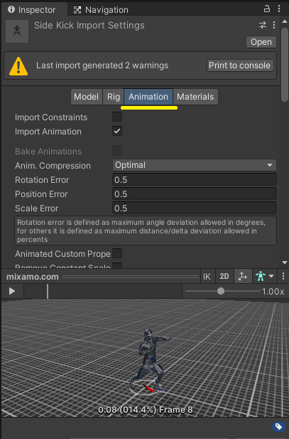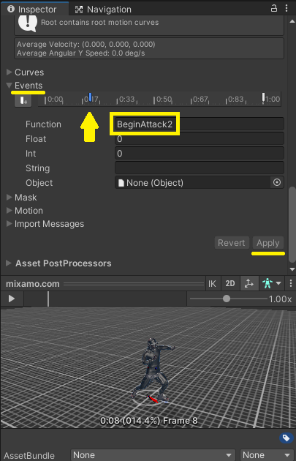

Lembre-se de fazer o mesmo processo para todos os eventos: BeginAttack1, BeginAttack2, EndAttack, EndHit.

Por fim, atualize as referências de objetos e componentes nos scripts Player e PlayerBody, no Inspector.

Recursos
- Computador, internet e Unity.

Observação
- Os assets e scripts estão disponíveis no Google Drive;
- Link para o download da Unity:
  - https://unity.com/pt/download
- Para as tarefas:

